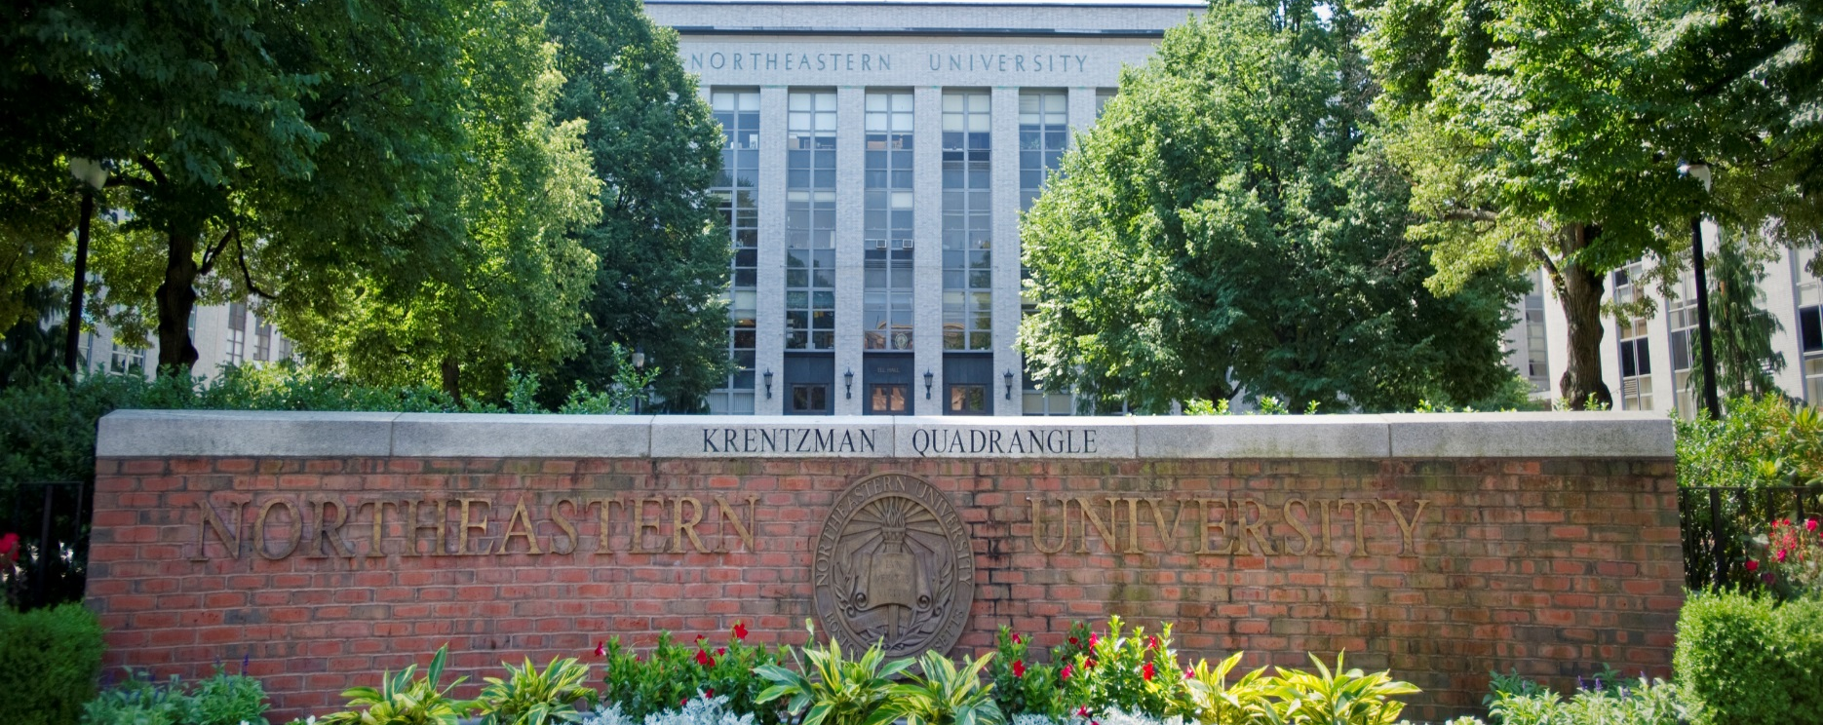

ELECTRICAL AND COMPUTER ENGINEERING
SEMINAR



Nathan Lazarus
Carnegie Mellon

Stretchable Magnetics for Soft Robotics

Monday, January 24th
Zoom Link:
https://northeastern.zoom.us/j/98976081080
1:00pm - 2:00pm

Abstract: Recent innovations in making robots from softer biofriendly materials have opened broad new applications ranging from medicine to agriculture. Due to the reliance of much of the field on pneumatic actuation, heavy and rigid pumps, and control circuitry for driving pressure chambers have become a major limitation for fully soft, untethered soft robots. In my talk, I will discuss all aspects of creating soft electromagnets, inductors and power circuits for electromagnetic actuation and power management in stretchable systems. Using unconventional materials like room temperature liquid metals and ferrofluids, we demonstrate record performance for a stretchable inductor. These stretchable inductors are then used to create flexible and stretchable pumps with flow rates nearly two orders of magnitude higher than past demonstrations in the literature and integrated into a simple soft robot demonstrator.

Bio: Nathan Lazarus has worked extensively in areas ranging from mixed signal electronics to MEMS fabrication, with his Ph.D. at Carnegie Mellon culminating in 2012 with the demonstration of the highest recorded fractional sensitivity to date for a capacitive chemical sensor topology integrated with CMOS electronics. Since joining US Army Research Laboratory in May 2012, Dr. Lazarus’s research has focused on stretchable power electronics, soft robotics and 3D printing. He has received numerous awards including ARL’s Honorary Award for Engineering and the Rookie of the Year Excellence in Federal Career Award (Gold) from the Baltimore Federal Executive Board. In 2019, Dr. Lazarus was selected for the Presidential Early Career Award for Scientists and Engineers (PECASE), the highest honor given by the US government for researchers beginning their independent research careers.

